|  |  |
| --- | --- |
|  | |
| Working With Data–Assessment 2  TU060 : Data Importing | |
|  | |
| Ciaran Finnegan – Part Time – First Year  Student No : D21124026  4/1/2022 |  |
|  |  |

Table of Contents

1 Description of Data Elements 3

1.1 Data Files 3

2 Data Import Process 4

2.1 General Approach 4

2.2 Loading the CSVs 5

3 Next Steps? 19

3.1 The Relational Data Model 19

# Description of Data Elements

## Data Files

The following are the list of CSV files that form the basis of the initial database set up in this assignment.

These data files contain the information to allow customer analysis within an imaginary telecommunications company.

Fig 1 – CSV File List With Customer Analysis Data

….

# Data Import Process

## General Approach

Using the built in ‘Import Data…’ option within Oracle SQl Developer was the most obvious approach to load the CSV files.

The first line of each CSV file contains a row with the text descriptions of the column names.

The following rows contain the actual customer/call/company information data.

Each file was loaded separately and SQL Developer auto generated the SQL Scripts that would execute the TABLE CREATE Statements and then INSERT the values stored in the CSV files.

This document will provide a detailed analysis, in Section 2.2.1, of the steps taken to load ***customers.csv*** into the assignment database.

**Each CSV file will go through a similar process but the subsequent sub sections in Section 2 will only provide a general overview, and call out the most significant data import issues.**

## Loading the CSVs

### Customer Data

Sample view of ***customers.csv*** file (in Notepad++).

Open the ‘Import Data…’ option within Oracle SQL Developer.

This launches the **Data Import Wizard**. Navigating to the local folder storing the data calls up the ***customers.csv*** file, and File Contents preview window is available.

The first row of the CSV file is correctly interpreted as the column names, which is the default setting in the ***File Format*** section.

The Import Method is set on the next Wizrd screen.

The name of the table to be created in out assignment database is set to ***tblCustomers***.

The ‘*tbl*’ prefix is a convention adopted during my time as a SQL developer with a former employee. The purpose was to label each database object according to type/purpose. Hence ‘tbl’ refers to a database table object.

The Import Method is set to ‘***Insert Scipt’*** because this output provides a SQL Script that contains both the CREATE TABLE SQL code, and the individual INSERT commands for each row of data. This is an option step but one which I chose because I felt it would provide more flexibility if I needed to re-create the assignment database

Column selection and ordering options are available on the **Choose Columns** (third) screen of the wizard.

All columns are selected and the ordering of attributes appears to be acceptable. No changes are required.

The **Column Definition** (fourth) screen of the Wizard objects to the format of the column names and flags four of them as Invalid in the list in source Data Columns.

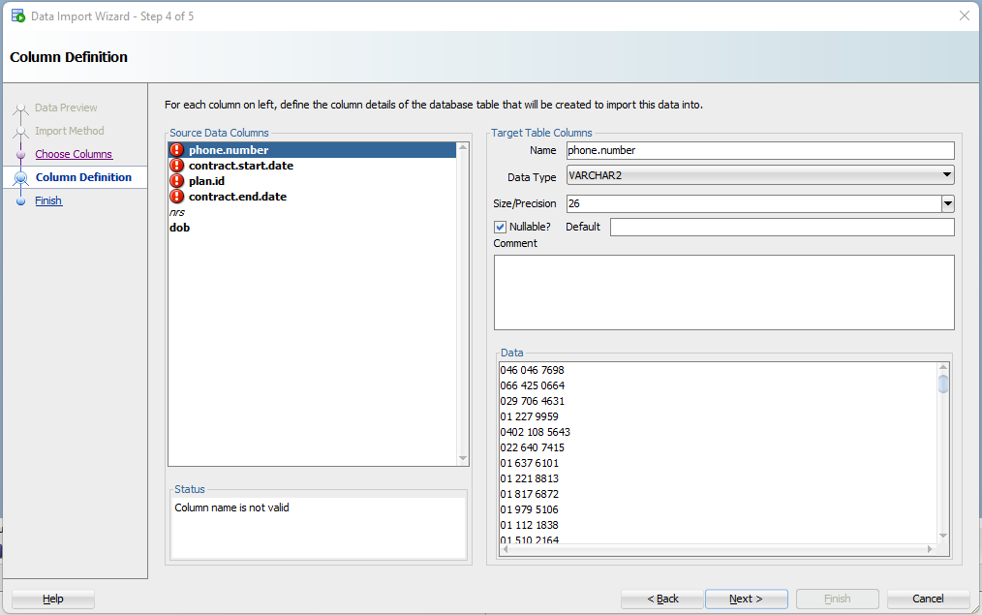

The ‘.’ character is not valid for column names. (A similar issue can be seen with data file uploads in SAS Studio).

To circumvent this issue the ‘.’ characters will be replaced with underscores (‘_’). The updates are made in the Target Table Colums section (see below).

***Phone_number***

This removes the error from the ‘phone_number’ colum but there are some additional considerations:

* The value is almost certainly going to be key value on the table and so we should not allow any ‘null’ entries. It will be essential for the integrity of the database that every row in this table has a unique phone number to identify the customer.
* Although this a phone number, the assumption is that we should leave the Data Type’ as VARCHAR2. This attribute is not really an integer, but an identifier in numeric format. For example, at a later stage tt could be necessary to carry out some sub-string analysis on number prefixes.
* The default precision size also seems satisfactory, or at least it is not necessary to change the default value.

***Contract_start_date***

Underscore characters removed the invalid warning for the contract start date, but the following changes were also required;

* The Data Type of ‘DATE’ appears to be correct but the ‘Format’ was changed to DD/MM/YYY. This is the format we will replicate across the other DATE columns.
* The value should ideally not be ‘null’ but we will not add a constraint.

***Plan_id***

Again, underscore characters removed the invalid warning for the contract start date, but the following changes were also required;

* The column should not allow ‘null’ values as each customer must be associated with a valid contract plan.

***Contract_end_date***

Underscore characters removed the invalid warning for the contract end date, but the following changes were also required;

* The default Data Type of VARCHAR2 needs to altered as this is a date attribute. The Data Type was changed to DATE and the ‘Format’ was set to DD/MM/YYY. This is the format we will replicate across the other DATE columns.

***Dob*** (date of birth)

Underscore characters removed the invalid warning for the date of birth (dob) attribute, and the following observartions applied;

* The Data Type of ‘DATE’ appears to be correct and the ‘Format’ was DD/MM/YYY. This is the format we will replicate across the other DATE columns.
* A ‘null’ value is acceptable.

Finish the process.

The data import and SQL Script generation process is not instantaneous, but when it completes the SQL is visible in SQL Developer.

Selecting the ‘Run Script (F5)’ option will execute the SQL to CREATE the *tblCustomers* table and INSERT all 5000 data rows.

### Call Data

Sample view of ***calls.csv*** file (in Notepad++).

Notes:

* Connection_id to the head of the table – not null.
* Phone_number – not null
* The Call_Time is imported as a text value (VARCHAR2(26). Ths will require conversion routines during the data model process but it was not possible to convert through the GUI at this point.

### Contract Plans Data

Sample view of ***contract_plans.csv*** file (in Notepad++).

Notes:

* Id – not null.
* Name – not null

### Call Rates Data

Sample view of ***call_rates.csv*** file (in Notepad++).

Notes:

* Call_type_Id – not null.
* Plan_id – not null
* Composite key – the above?

### Customer Service Data

Sample view of ***customer_service.csv*** file (in Notepad++).

Notes:

* connection_id – not null (key) and moved to top
* call_time – stays as VARCHAR2 – hard to convert to timestamp
* call_type_id – move to second place

### Rate Type Data

Sample view of ***rate_types.csv*** file (in Notepad++).

Notes:

* id – not null (key)
* name – not null

### Social Grade Data

Sample view of ***social_grade.csv*** file (in Notepad++).

Notes:

* Grade – not null (key), also need to remove padded blanks
* Social class – not null

### Voicemails Data

Sample view of ***voicemails.csv*** file (in Notepad++).

Notes:

* Connection_id – not null (key), moved to top, maybe look at size?
* Phone number – not null
* Call_time – same issue with converting to timestamp

# Next Steps?

## The Relational Data Model

The ...